SOLUTIONARCHITECTURE

|  |  |
| --- | --- |
| Date | 19September2022 |
| TeamID | PNT2022TMID01551 |
| ProjectName | Project - A Novel Method for Handwritten Digit Recognition System |
| MaximumMarks | 4Marks |

# PROJECTDESCRIPTION:

Everyone in the world has a unique writing style, handwriting identification is oneof the fascinating research projects now being conducted. It is the ability of acomputertoautomaticallyrecognizeandcomprehendhandwrittennumbersorletters.Every aspect of life is being digitized to lessen the need for human labor asa result ofadvancements in science and technology. Thus, handwritten digit recognition isrequired in many real-time applications. The MNIST data collection, which contains70000 handwritten digits, is frequently utilized for this recognition method. In orderto train these photos and create a deep learning model, we use artificial neuralnetworks. A web application is developed that allows users to upload pictures ofhandwritten numbers. The model examines this image and the detected result isreturnedtotheUI.

# TECHNICALARCHITECTURE:

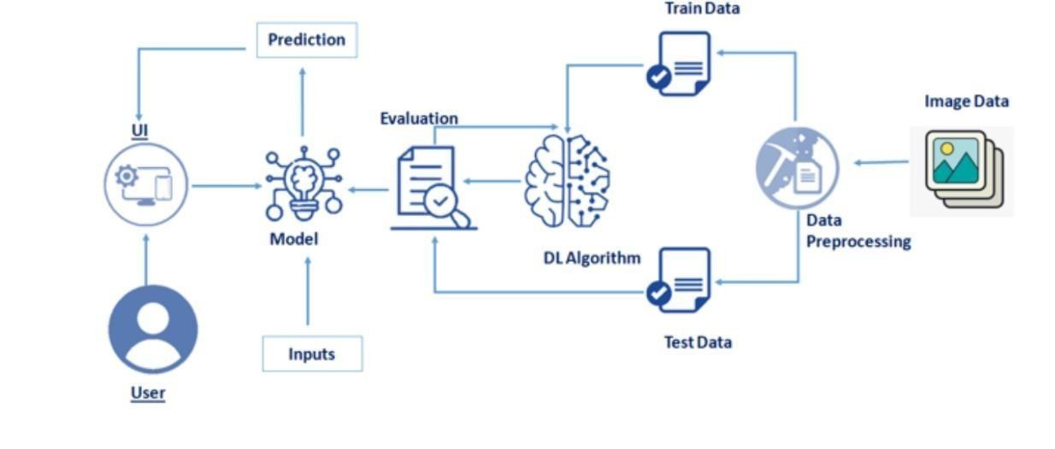

**SOLUTION:**

**MNISTDatasetDescription:**

Because everyone in the world has a unique writing style, handwritingidentification is one of the fascinating research projects now being conducted. Itistheabilityofacomputertoautomaticallyrecogniseandcomprehendhandwritten numbers or letters. Every aspect of life is being digitized to lessenthe need for human labor as a result of advancements in science and technology.Thus, handwritten digit recognition is required in many real-time applications.TheMNISTdatacollection,whichcontains70000handwrittendigits,isfrequently utilized for this recognition method. In order to train these photos andcreateadeeplearningmodel,weuseartificialneuralnetworks.Awebapplicationis developed that allows users to upload pictures of handwritten numbers. Themodelexaminesthispicture.

The 60,000 training and 10,000 testing labeled handwritten digit images intheMNISTHandwrittenDigit RecognitionDataset.

Eachimagehasatotalof784(2828)pixels,or28 pixelsinheightand 28pixels in width. There is just one pixel value assigned to each pixel. It displaysthe brightness or darkness of that pixel (larger numbers indicate darker pixel).Theintegerforthispixelvaluerangesfrom0 to 255.

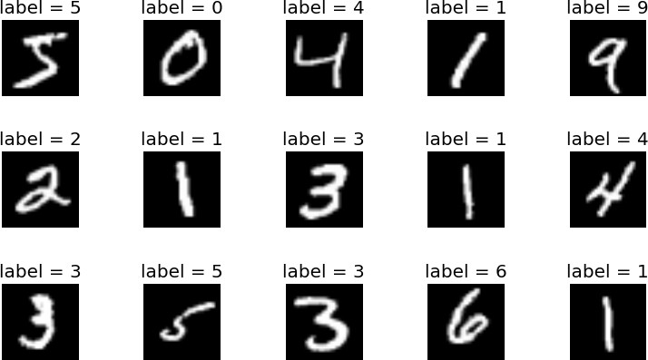

# PROCEDURE:

* InstalltheTensorFlowlibrary.
* Preparethemodel'sdataset.
* Forthepurposeofclassifyingthehandwrittendigits,createasinglelayerperceptronmodel.
* Plottheaccuracychangeovertime.
* Analyzethetestdatatoevaluatethemodel.
* Speculateonthemodelsummary.
* Tomakethemodelamulti-layerperceptron,addahiddenlayer.
* Toavoidoverfittingandassessitsimpactonaccuracy,includeDropout.
* Increasethenumberofhiddenlayerneuronsandassesshowaccuracyisaffected.
* Testtheimpactofvariousoptimizersonaccuracy.
* Increasethehiddenlayersandassesstheaccuracyimpact.
* Changethebatchsizeandepochs,thenassesstheimpactonaccuracy.

Fortherecognitionofhandwrittendigits,theMNISTdatasetisfrequentlyused. 10,000 test photos make up the dataset, which includes 60,000 trainingimages. The discipline of image processing relies heavily on artificial neuralnetworksbecausethey most closelyresemblethehumanbrain.

Asignificantprojectdonewiththeuseofneuralnetworksistherecognition of handwritten digits using the MNIST dataset. In essence, itrecognizesdigitsthatwerescribbledandscanned.

Our handwritten digit identification system goes a step further in that itcannowrecognizehandwrittennumberstypeddirectlyonthescreenwiththeaidofanintegratedGUIin additiontodetectingtheminscannedphotos.

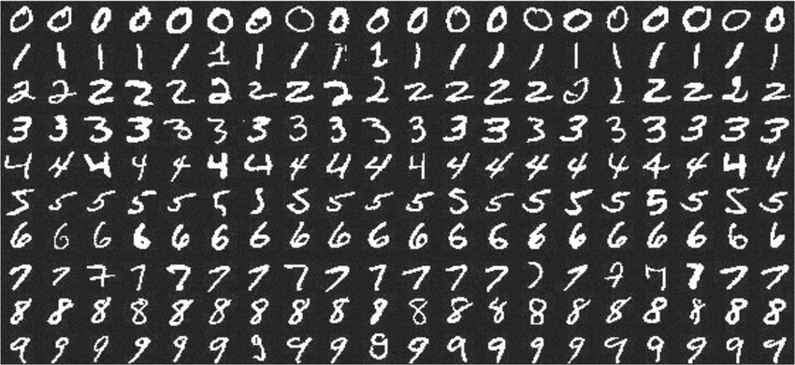

# APPROACH:

Thisprojectwillbeapproachedutilizingathree-layeredneuralnetwork.

* + **The input layer:** The input layer transfers the information fromour example systems to the following layer so that the latter cancomputeitsactivations.
  + **The hidden layer:** The network's nonlinear ties are provided byhiddenunitstermedactivationsthatmakeupthehiddenlayer.Dependingonourneeds,therecanbeavarietyofconcealedlayers.
  + **The output layer:** The nodes in this stratum are referred to as outputunits.Itgivesusaccesstotheneuralnetwork'sfinalprediction,whichmaybeusedtomakefinalpredictions.

A neural network is a model of the brain's operations. It is made up ofnumerous layers with a variety of activations; these activations mimic theneurons in our brain. An attempt is made by a neural network to learn a set ofparameters from a set of data that might aid in understanding the underlyingrelationships.Sinceneuralnetworksarecapableof adaptingtochanginginput,thenetworkcanproducethebestoutcomewithouthavingtochangetheoutputcriterion.

# METHODOLOGY:

Aneuralnetworkwithonehiddenlayerand100activationunitshasbeenputintopractice(excludingbiasunits).Thefeatures(X)andlabels(Y)wereretrievedafterthedatawasloadedfroma.matfile.Topreventoverflowduringcomputation, features are then scaled into a range of [0,1] by dividing by 255.10,000 testing cases and 60,000 training examples make up the data. With thetrainingdata,feedforwardisusedtocalculatethehypothesis,andbackpropagation is then used to lower the error between the layers. To combatoverfitting, the regularization parameter lambda is set to 0.1. To identify themodelthat fitsthesituationtheoptimizerrunsfor70times.

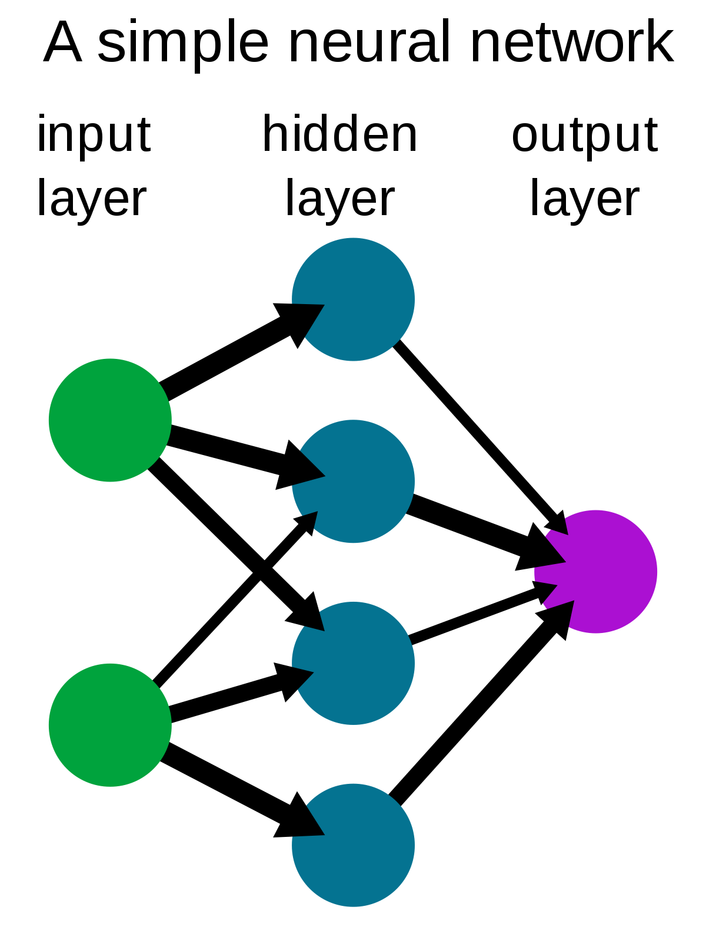

# ALGORITHM:

**ForwardPropagationArchitecture:**

A simple process for the CNN module's feature extraction and pictureclassification is shown below. The network's input layer, hidden layers, andoutputlayerarealldisplayedinthearchitecture.Thefeatureextractionphaseof the network involves multiple layers and uses convolution andsubsampling.

# EXPLANATIONFORTHEPROPOSEDSYSTEM

* The User layer is the top layer of the architecture. The users who engagewiththeprogrammeandgetthedesiredoutcomesmakeuptheuserlayer.
* Thefrontendarchitectureoftheapplicationismadeupofthefollowingthreelevels.
* Theapplicationwillbecreatedontheopen-sourceJavaScript,CSS,andHTMLplatform.

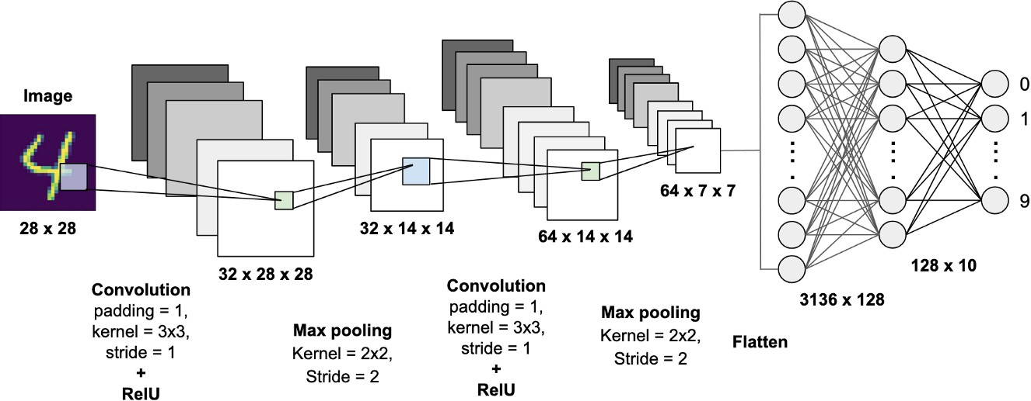

* Thelocalhost,whichisdisplayedinthebrowser,iswheretheprogrammeis deployed. The user will be able to upload images of the handwrittennumberstotheapptohavethemdigitized.
* The business layer, which consists of logical calculations based on theclient's request, sits between the database and view layers. The serviceinterfaceisalsoincluded.
* Training Data and Test Data make up the backend layer's two datasets. Thetraining set, which consists of 60,000 cases, and the test set, which consistsof10,000examples,havealreadybeenseparatedintotheMNISTdatabase.
* A convolution neural network is utilized as the training algorithm. Thiswillget thetrained modelreadytoclassifythedata.

# WORKING:

* Afterreceivinganinput,neuralnetworkschangeitusinganumberofhiddenlayers.
* Eachgroupofneuronsinahiddenlayeriscompletelylinkedtoeveryotherneuroninthelayeraboveit.
* Onelayerofneuronshaveperfectindependencefromoneanother.
* The"outputlayer"isthefinallayertobefullyconnected.

# CONVOLUTIONLAYER:

The foundational component of a CNN is the convolutional layer. Theparametersofthelayerareasetoflearnablefilters(orkernels)thatcovertheentiredepthoftheinputvolumebuthaveanarrowreceptivefield.

Each filter is convolved across the width and height of the input volumeduring the forward pass, computing the dot product between each filter entryandtheinputto createatwo-dimensionalactivationmapofthefilter.

As a result, the network picks up filters that turn on when it detects acertainkindoffeatureataparticularspatiallocationin theinput.

# FEATUREEXTRACTION:

Allneuronsinafeaturesharethesameweights.Inthiswayallneuronsdetect the same feature at different positions in the input image. Reduce thenumberoffreeparameters.

# SUBSAMPLINGLAYER:

Subsampling,ordownsampling,referstoreducingtheoverallsizeofasignal. The subsampling layers reduce the spatial resolution of each featuremap.Reducetheeffectofnoisesandshiftordistortioninvariantisachieved.

# POOLINGLAYER:

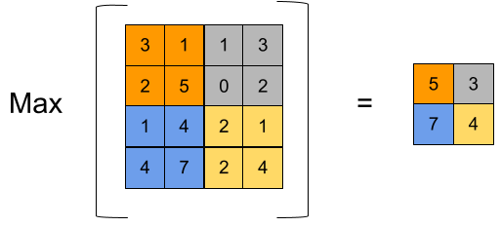

ItiscommontoperiodicallyinsertaPoolinglayerin-betweensuccessiveConv layer in a Convent architecture. Its function is to progressively reducethe spatial size of the representation to reduce the number of parameters andcomputation in the network, and hence to also control overfitting. The PoolingLayer operates independently on every depth slice of the input and resizes itspatially,usingtheMAXoperation.

# TENSORFLOW:

An open-source machine learning library for both research and production iscalled TensorFlow. TensorFlow provides developers of all skilllevels with APIs fordesktop, mobile, web, and cloud applications. To get started, refer to the sectionsbelow. We can achieve text output and sound output by scanning the number digitandconvertingit toPNGformatusing thepython3 commandin theterminal.

# RESULT:

Aswithanystudyorprojectconductedinthefieldsofmachinelearningandimageprocessing,wedonotconsiderourresultstobeperfect.

Because machine learning is a field that is constantly evolving, there isalwaysroomforimprovementinyourapproaches.Therewillalwaysbeabrand-newconceptthatmoresuccessfullyaddressesacertainissue.Theapplicationwasevaluatedusingthreemodels:Multi-LayerPerceptron(MLP),ConvolutionNeural Network, and (CNN). With each model, we get a different classifieraccuracy,showingwhichisbetter.